TKE Webmaster Manual

**OLD WEBSITE:** [**http://stu.cbu.edu/Clubs/tke/**](http://stu.cbu.edu/Clubs/tke/)

1. Download WinSCP: <https://winscp.net/eng/download.php>
2. When training a new webmaster, send an email to ITS stating that you would like to transfer the TKE website rights to the new webmaster so that he may make changes to the website. Additionally, it is advised to go through this guide with the new webmaster, and let the new webmaster make the changes on his own time in order to learn/ask questions.
3. Login
   1. Host name: sheba.cbu.edu
   2. Port number: 22
   3. User name: your cbu username used to login to school computers
   4. Password: your cbu password used to login to school computers
   5. Trust the host fingerprint upon first login
4. Navigating to the TKE directory
   1. In the dropdown menu, navigate to the <root> directory
      1. 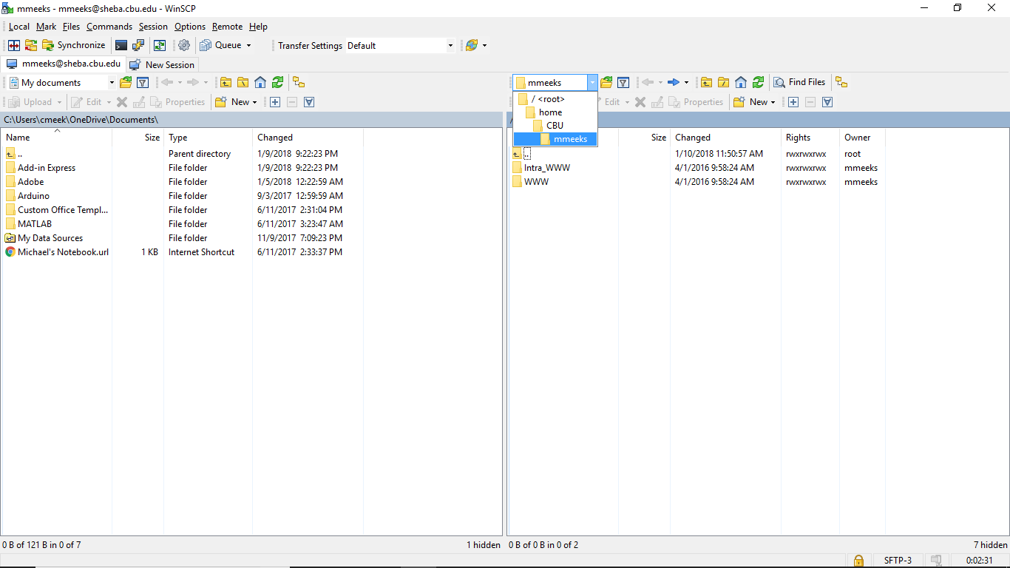NOTE: do not choose “home”. Navigating to the home directory will result in a crash. You must abort the session and reconnect.
   2. Next follow the directories to the TKE website files
      1. /var/www/html/Clubs/tke
         1. NOTE: sometimes, it will take longer (20 seconds) to open the Clubs folder, just wait, don’t abort
      2. If at any time you wish to go back a directory click the “..” directory with the back arrow icon.

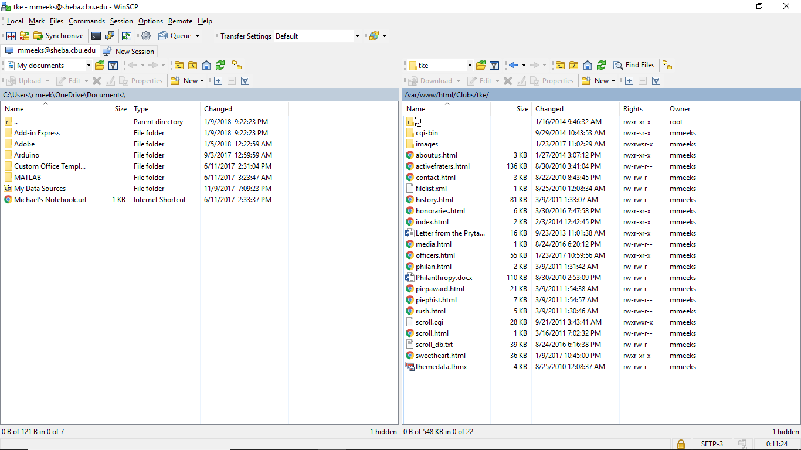

1. Making a Backup
   1. NOTE: Before making any changes, it is recommended to make a backup of all the files in the case of a disaster.
   2. 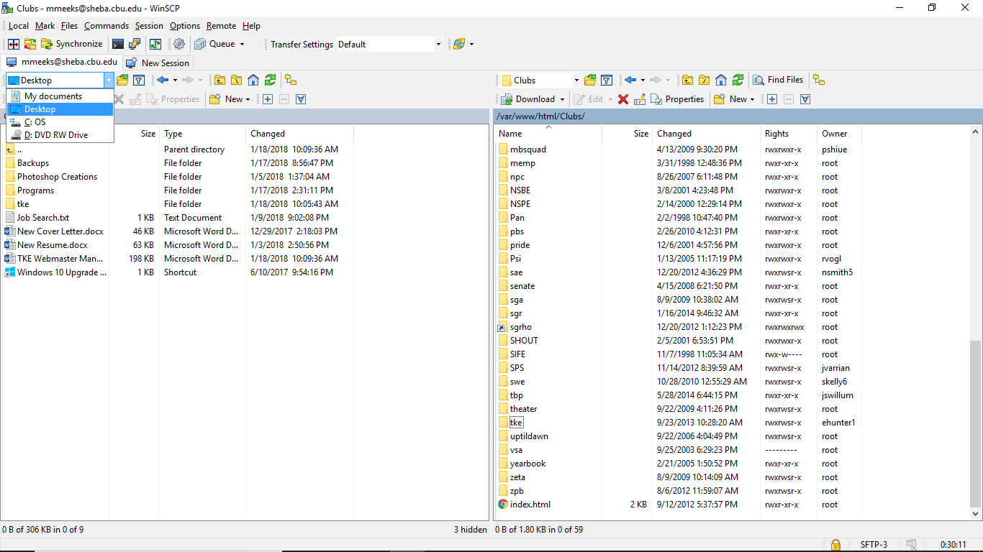On the left hand side (your files) use the dropdown menu to navigate to a location you would like to make the backup (I will use the desktop)
   3. On the right of WinSCP, Go back a directory to “Clubs” by clicking the click the “..” directory with the back arrow icon.
   4. Right click on the “tke” directory and click “Download”
   5. Browse to the correct location of where you would like to store the backup
   6. Wait for it to download (1 minute)
   7. Now you have a backup to revert to if something goes wrong. Do not make changes to this backup. Make all your changes in WinSCP.
2. Making changes to the website
   1. NOTE: BE VERY CAREFUL – many of these documents contain important metadata that allows the website to function properly. Whenever you make a change, be sure to revert that change if it is something you did not want to do. Additionally, there are a lot of redundant files in the system. You must go through and see which ones actually make changes to the website)
   2. The Scroll
      1. You can retrieve the most recent scroll from your Grammateus
      2. Navigate to “cgi-bin” within the “tke” directory
      3. Open “scroll_db.txt” to view/edit the scroll
      4. Go to the bottom to add a new member.
      5. Copy and Paste the entire line of most recent frater to keep format
      6. NOTE: Leave Chris Albonetti at the very bottom (his name should stay there)
      7. The format of each line is

[Scroll Number]:[Name]:[Big Brother Scroll Number]:[AC/AL for Active/Alumni]:[Nickname] [other colon]

550:Connor Meeks :537:AL:Pledge : : : :

* + 1. NOTE: it is very important to keep the same format. Do not use any tabs. The space between the colons is generated using the Spacebar.
    2. If at any time you need to XXXXXXX out a frater, place a “Y” between the last set of colons: “: : :Y:” The other two sets of colons are used for Chris Albonetti’s Chapter and Scroll number
    3. Once you have made the changes, click the Save button in the top left hand corner.
    4. Return to the Tke website to make sure your changes have occurred.
    5. Make sure to change all the actives to alumni (AC -> AL) once they have graduated. (this will remove the red color from their names)
  1. The Officers **(must be on a CBU computer)**
     1. Navigate to “officers.html” in the “tke” directory. Right click and edit
     2. For each officer we must change 3 things
        1. Image source
           1. Find a professional picture on Facebook of the new officer. Crop a SQUARE to prevent stretching.
           2. Save the Image to the “images” directory in the “tke directory. The file name should follow the convention [First Letter of first name, last name].jpg

Example: for Connor Meeks, the file name should be CMeeks.jpg

* + - * 1. In “officers.html” use (control + f) to search for a keyword. If we were trying to replace CMeeks.jpg, we would use a search to find the phrase “CMeeks”. The location of this image source should appear in the search.
        2. Replace the old image source with the new one (changing pictures)
        3. src="images/CMeeks.jpg" alt="Connor Meeks"
      1. Alt source
         1. The Alt source is a backup incase the image doesn’t load correctly.
         2. Replace the old officer’s name with the new officer
         3. src="images/CMeeks.jpg" alt="Connor Meeks"
      2. Name
         1. Finally, we must change the name next to the picture on the website. Below the source, there is a space to fill this name in
         2. color:#333333'>Connor Meeks</span></p>

**NOTE: sometimes a past officer becomes a new officer in a higher position.**

* + - * 1. A good rule of thumb is to first update officer positions where the past officer will become a new officer.
        2. *For instance, if Connor Meeks was chaplain last year, and will become President this year: It would be better to replace the chaplain position first. If we left Connor Meeks in chaplain and updated Connor Meeks to be president too, then there would be multiple instances of Connor Meeks in the officers. This could lead to confusion.*

1. Chairmen
   * + - 1. Use (control + f) to find the chairman you want to change. If Connor Meeks was the old Rush chair search the phrase “Connor Meeks” and replace it. (To cross reference, a few lines below will have the chair position associated with the person)
2. Moderator/Advisor
   * + - 1. Use (control + f) to find the moderator/advisor you want to change.
   1. The Honoraries **(must be on a CBU computer)**
      1. Navigate to “honoraries.html” in the “tke” directory. Right click and edit
      2. 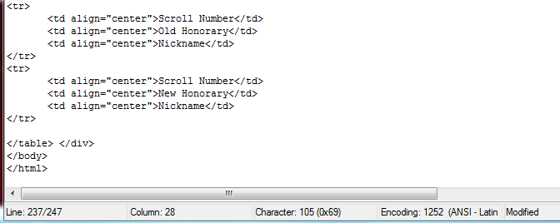You can change an honorary information. You can add a new honorary by following the format. Just copy and paste the block of code underneath the last honorary. Make sure to save and check the website after changes are made.
   2. The Sweetheart **(must be on a CBU computer)**
      1. Navigate to “sweetheart.html” in the “tke” directory. Right click and edit
      2. Update 2 instances of the full name of the new sweetheart
         1. color:#333333'>Jane Doe</span></b>
         2. src="images/JDoe.jpg" o:title="Jane Doe"/>
      3. Update 4 instances of the file name referencing the image
         1. alt="JDoe.jpg"
         2. src="images/JDoe.jpg" o:title="Jane Doe"/>
         3. src="images/JDoe.JPG" alt=JDoe.JPG
      4. Update Major, Year and Sorority Fields by using (control + f ) to find
      5. Find a professional picture on Facebook of the new sweetheart. Crop a SQUARE to prevent stretching.
      6. Save the Image to the “images” directory in the “tke directory. The file name should follow the convention [First Letter of first name, last name].jpg
         * 1. Example: for Jane Doe, the file name should be JDoe.jpg
      7. Save and check save on website.
   3. Any other pages **(must be on a CBU computer)**
      1. Find the file in WinSCP associated with the page you are trying to update.
      2. Make changes as necessary.

**NEW WEBSITE:** [**http://www.tkepiep.com/**](http://www.tkepiep.com/)

1. This website is linked to the TKE module. Therefore, it is mostly automated. All additions of new members and officers will automatically update whenever the module updates. Encourage your active fraters to update their profile pictures on the module to show on the members page.
   1. Module Link: <https://module.tke.org>
   2. Website Info Page: <http://www.tke.org/resources/chapter-websites>
2. Any member of the EC can edit this website.
3. To edit this website you must login. Scroll to the bottom right of the website and press the Login Icon
4. Once inside, you can edit Pages, External Links, Newsletters, Events, Media, and many other options. It is up to the Webmaster of how much detail will go into this site.
5. For more technical support on this new website, contact [support@tke.org](mailto:support@tke.org)

If you may have any questions or concerns please feel free to contact your previous webmaster, or Connor Meeks at [cmeeks96@gmail.com](mailto:cmeeks96@gmail.com) 901-634-7400